**📈 Sales Performance**

1. ***Total Sales over time***

SELECT

SUM (Sales)

FROM train;

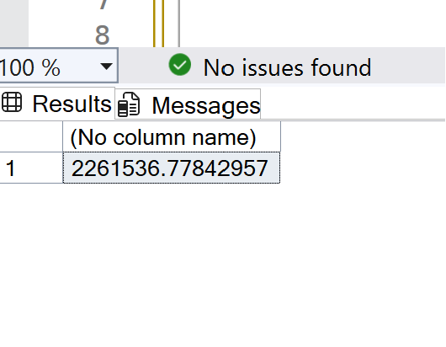

2. ***Total monthly Sales over time***

1. SELECT
2. FORMAT([Order_Date], 'yyyy-MM') AS OrderMonth,
3. SUM(Sales) AS TotalSales
4. FROM
5. train
6. GROUP BY
7. FORMAT([Order_Date], 'yyyy-MM')
8. ORDER BY
9. OrderMonth;

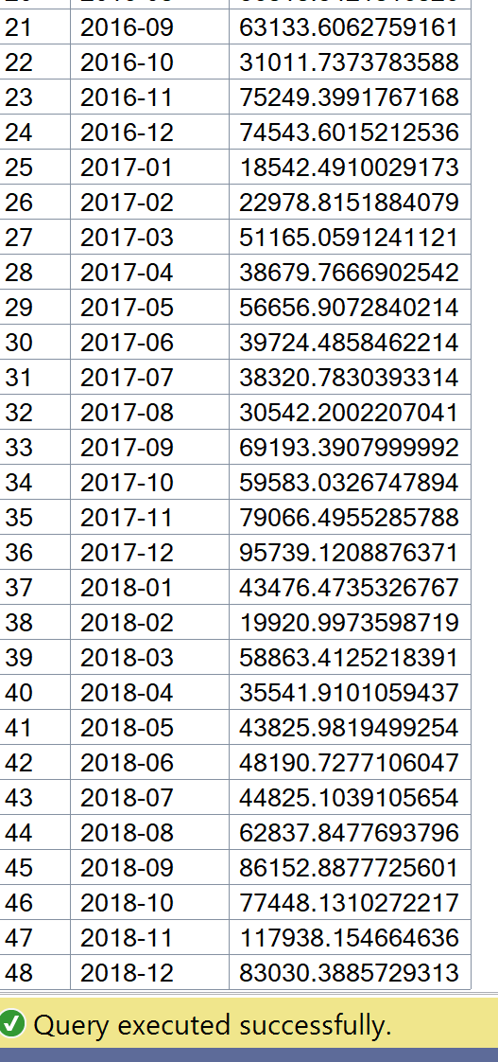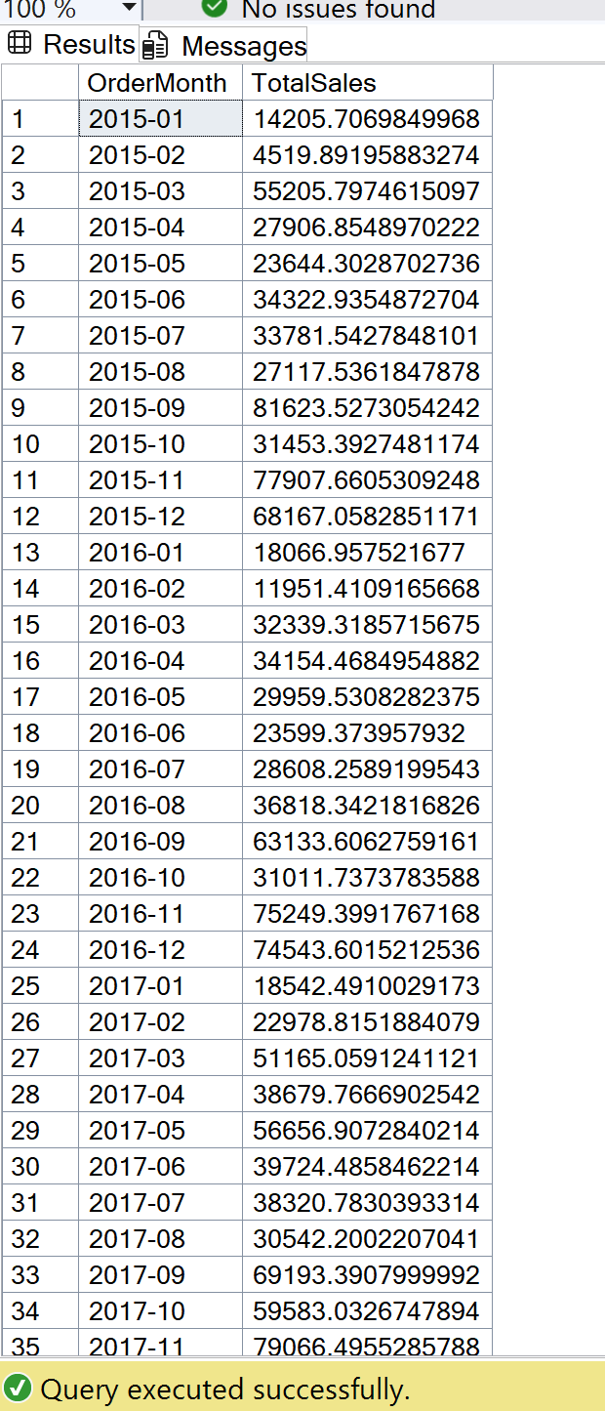

3.***Total yearly sales***

SELECT

YEAR([order_date]) as yearlyorder,

SUM(sales) as totalsales

FROM train

GROUP BY YEAR([order_date])

ORDER BY

yearlyorder;

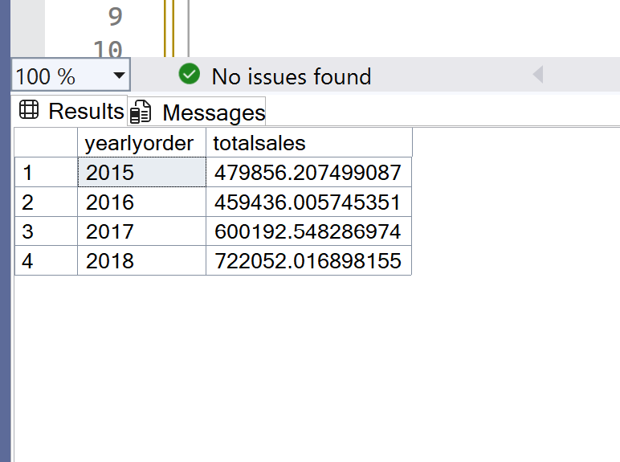

***4.Top-10 selling product***

***N.B. To ensure clarity and maintain a clean layout in this portfolio, I limited the output to the Top 10 selling products.***

SELECT

TOP 10

[Product_Name],

SUM (Sales) AS totalsales

FROM train

GROUP BY [Product_Name]

ORDER BY totalsales DESC

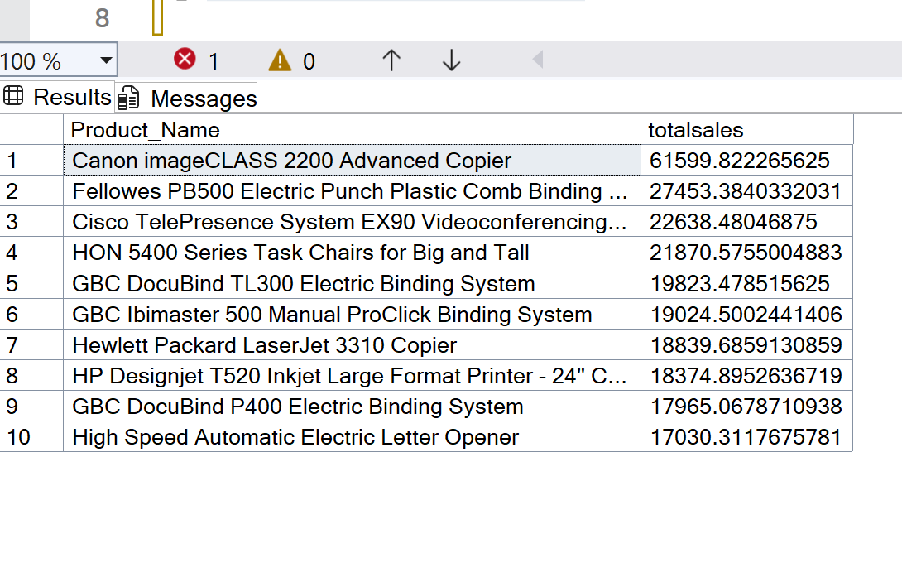

***5.Sales by category & sub category***

SELECT

[Sub_Category],

[Category],

SUM (sales) as totalsales

FROM train

GROUP BY [Category],[Sub_Category]

ORDER BY totalsales DESC;

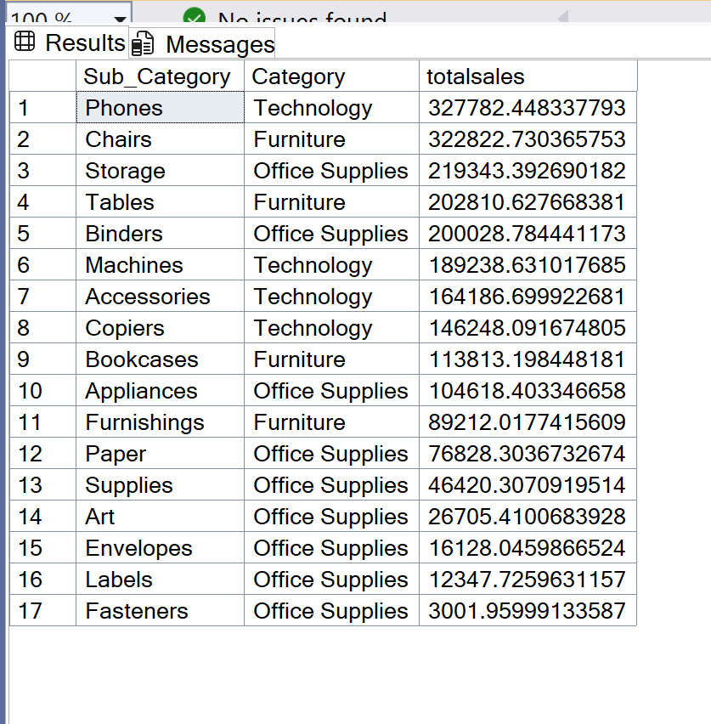

6. ***Sales by region*** ***top 50***

***N.B. To ensure clarity and maintain a clean layout in this portfolio, I limited the output to the Top 50 sales by region.***

SELECT

[Country],

[City],

SUM (sales) as totalsales

FROM train

GROUP BY [Country],[City]

ORDER BY totalsales DESC;

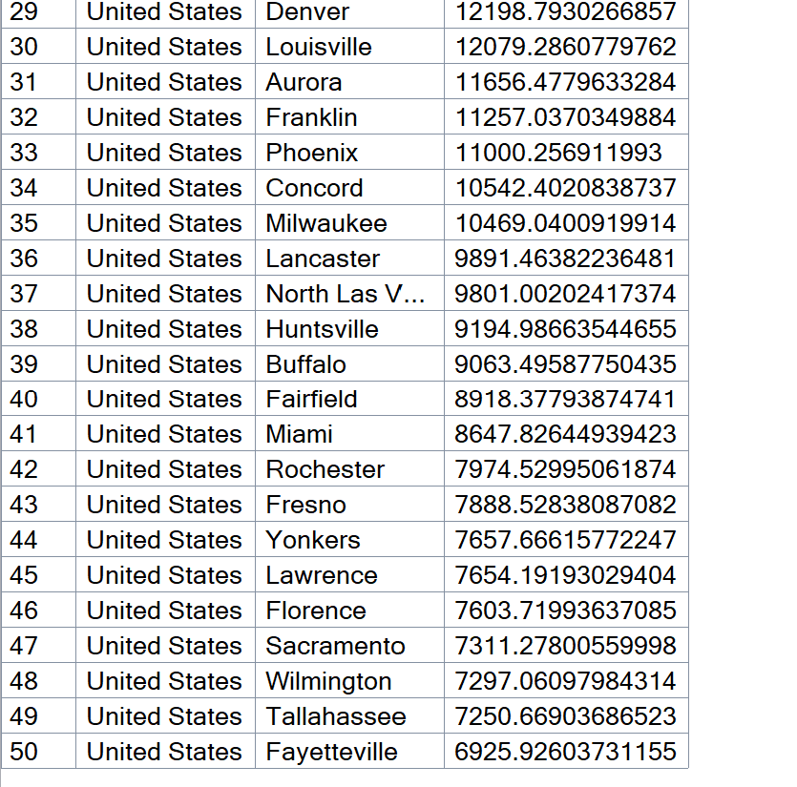 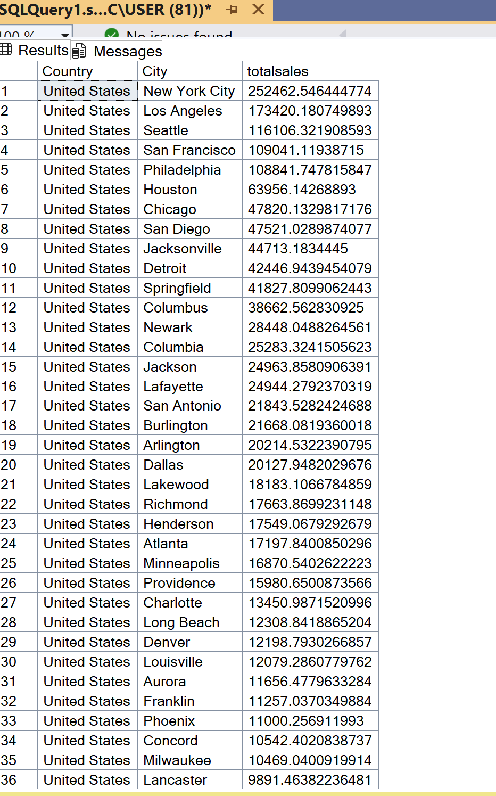  
  
7. ***Average amount sales***

SELECT

avg (sales)

FROM train

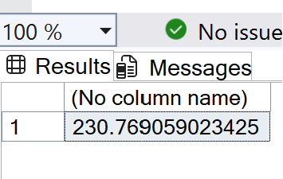

👥 **Customer Analysis**

***1.Top 50 customers by total sales***

***N.B. To ensure clarity and maintain a clean layout in this portfolio, I limited the output to the Top 50 customers who made the top sales.***

SELECT

[Customer_Name],

[Customer_ID],

SUM (sales) as totalsales

FROM train

GROUP BY [Customer_Name],

[Customer_ID]

ORDER BY totalsales DESC;

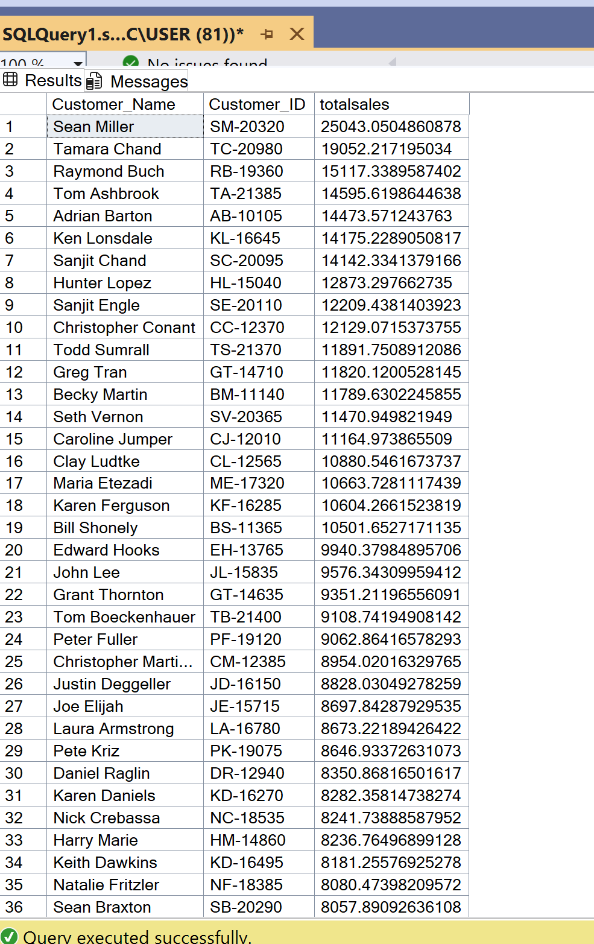 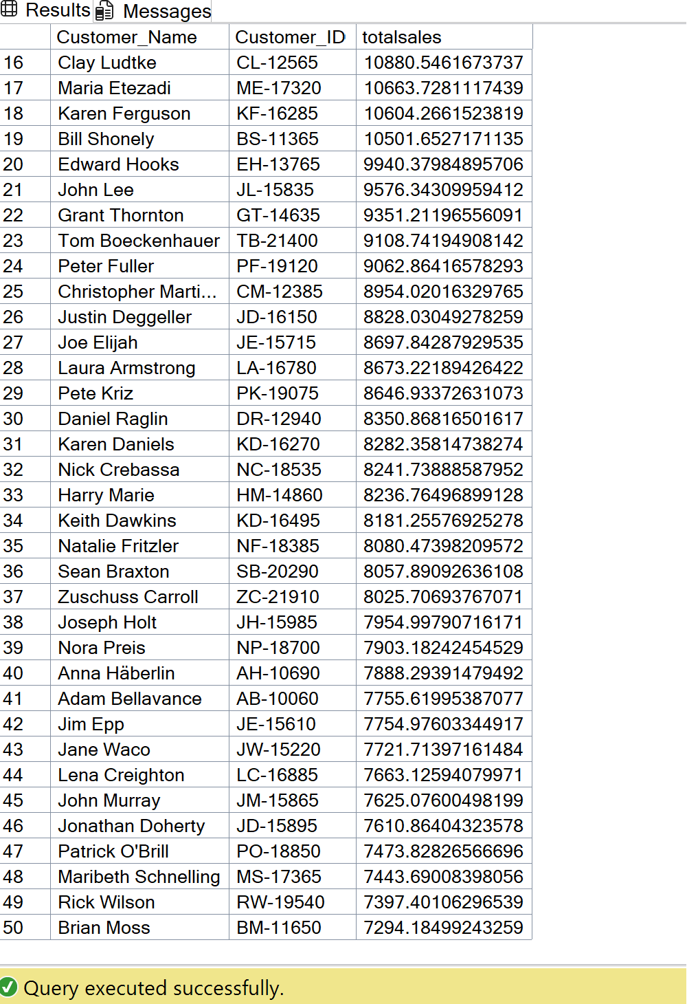

***2.Top 50 Customer repeat rate (how many made multiple purchases)***

***N.B. To ensure clarity and maintain a clean layout in this portfolio, I limited the output to the Top 50 customers who made multiple purchases.***

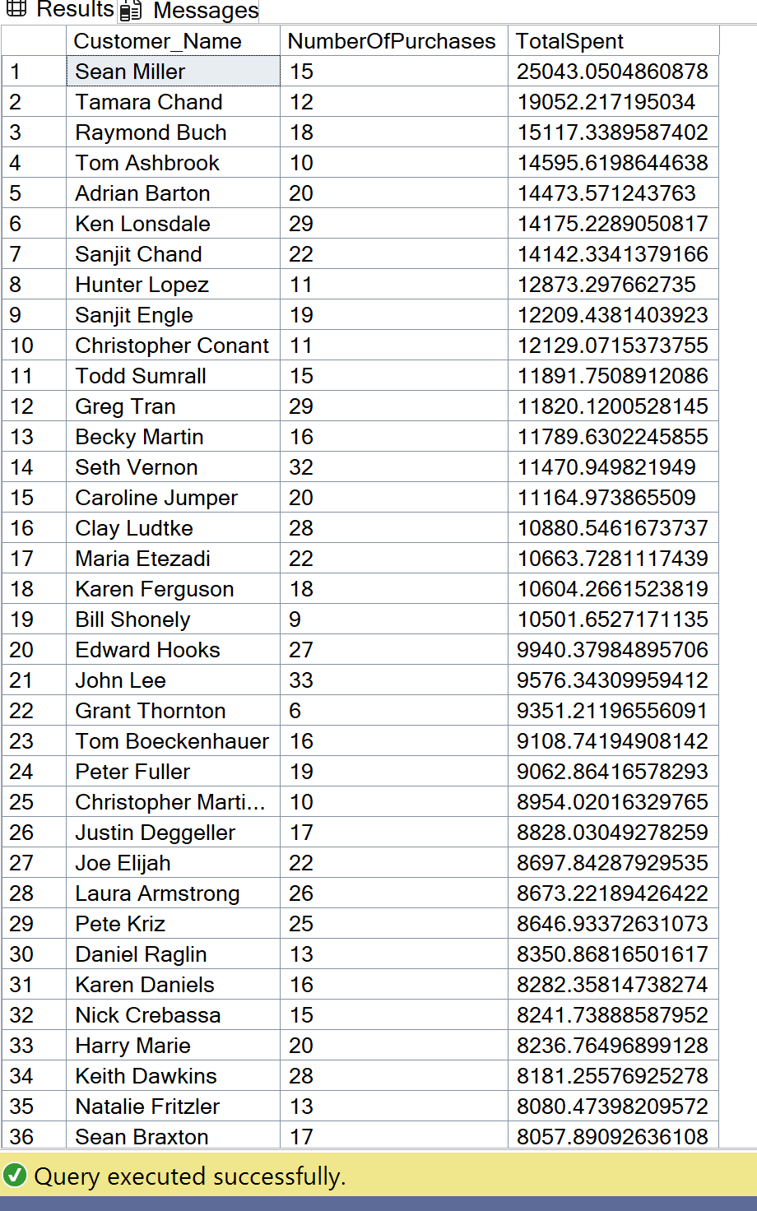 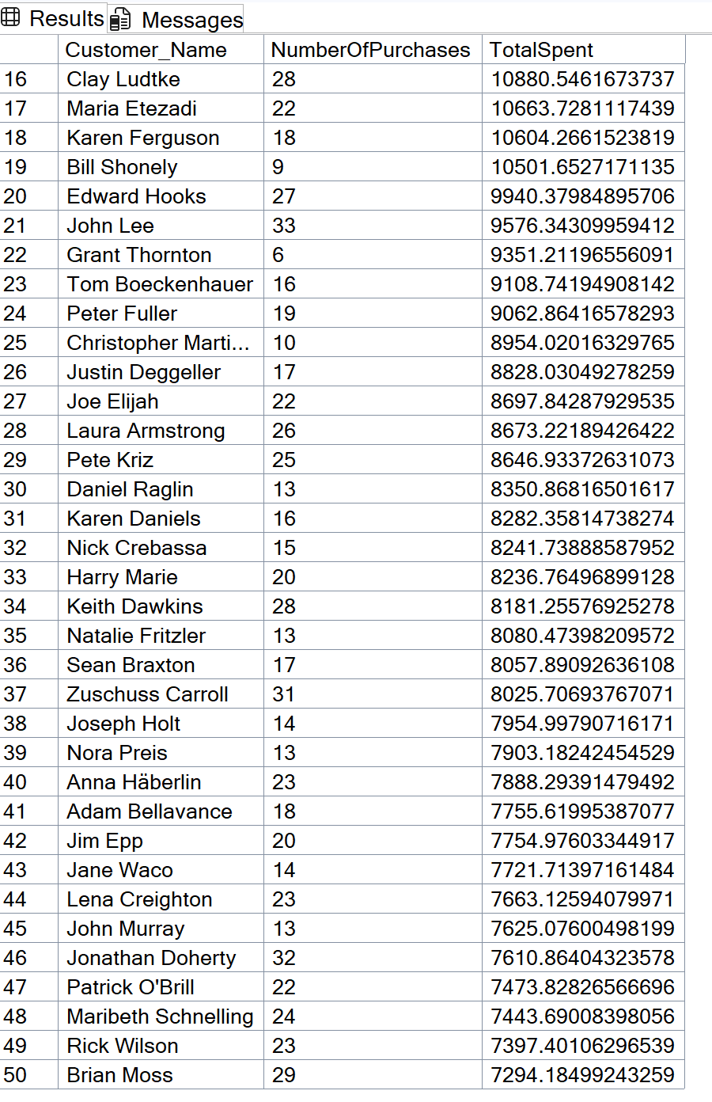

1. ***Total unique customers***

SELECT

COUNT (DISTINCT Customer_Name)

FROM train

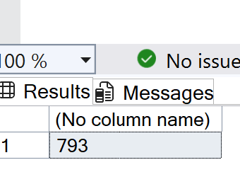

**Geographical Insights**

***Regional product preferences***

SELECT

COUNT (*) AS preferences_count,

(Region),

Category

FROM train

GROUP BY

Region,Category

ORDER BY preferences_count DESC, Region, Category;

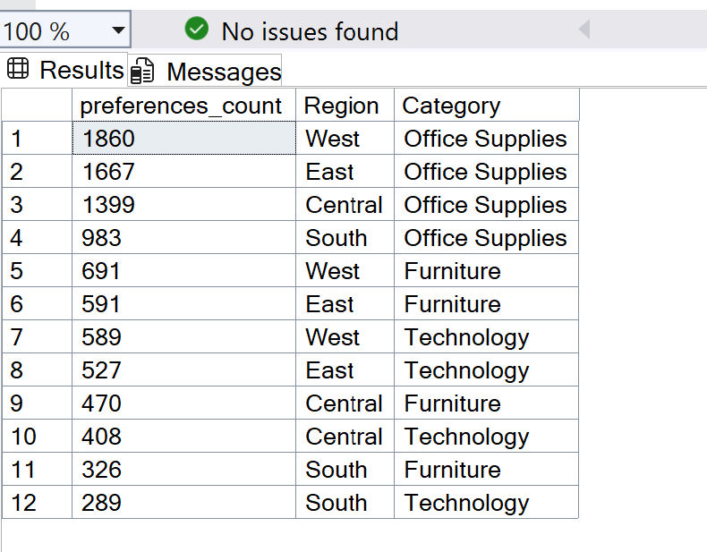

**Shipping Analysis**

***Average shipping time (Ship Date - Order Date)***

SELECT

AVG(DATEDIFF(DAY, [Order_Date], [Ship_Date])) AS AverageShippingDelay

FROM

train;

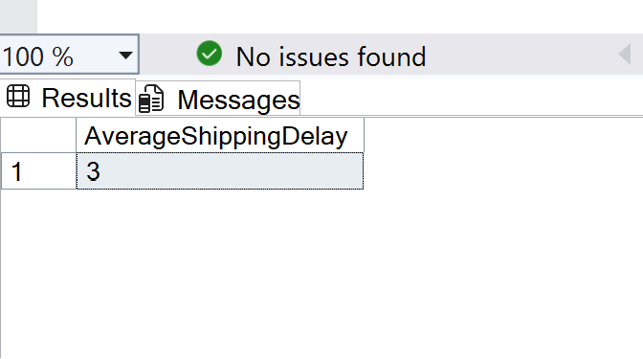

***Most preferred Shipping mode and total shipment by ship mode***

SELECT

Ship_Mode,

count(*) as totalshipment

FROM train

GROUP BY Ship_Mode

ORDER BY totalshipment DESC

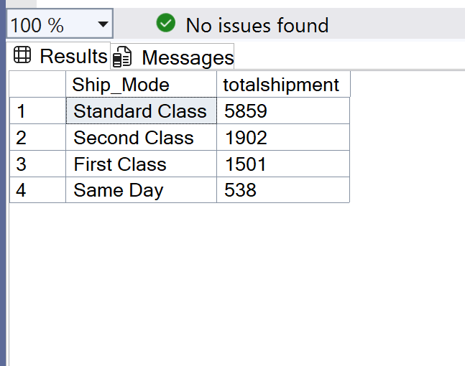

***Total sales by ship mode***

SELECT

Ship_Mode,

SUM(Sales) AS TotalSales

FROM

train

GROUP BY

Ship_Mode

ORDER BY

TotalSales DESC;

